**Bubble Sort**

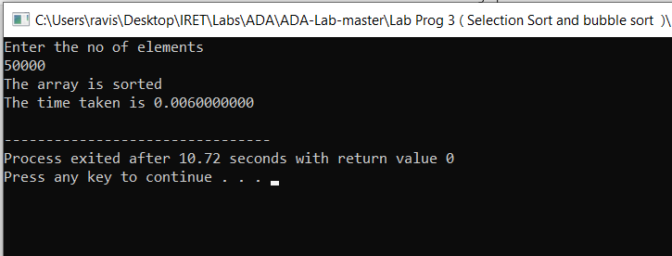

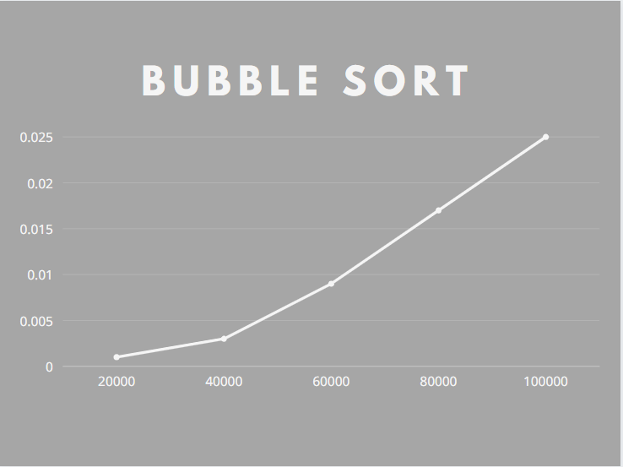

|  |  |
| --- | --- |
| Bubble Sort  Array size | Time in sec |
| 20000 | 0.001 |
| 40000 | 0.003 |
| 60000 | 0.009 |
| 80000 | 0.017 |
| 100000 | 0.025 |

**Selection Sort**

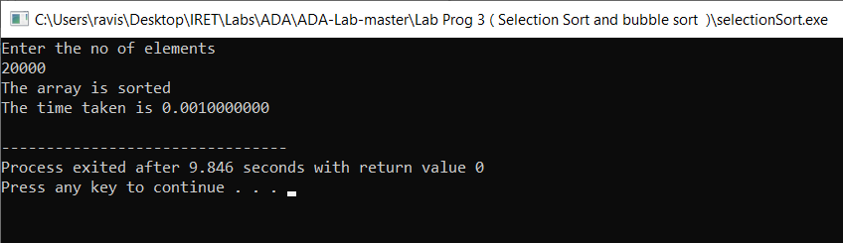

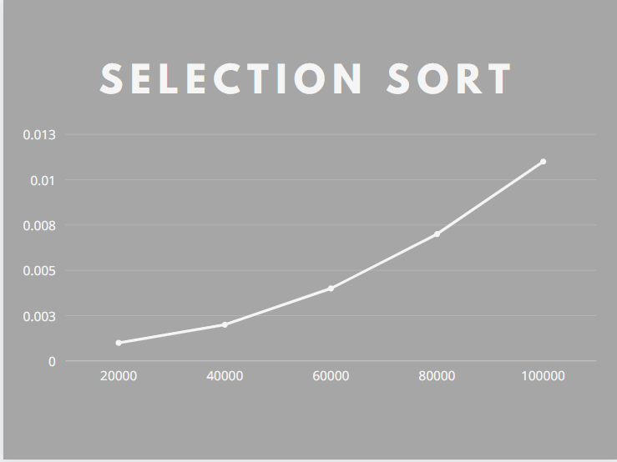

|  |  |
| --- | --- |
| Bubble Sort  Array size | Time in sec |
| 20000 | 0.001 |
| 40000 | 0.002 |
| 60000 | 0.004 |
| 80000 | 0.007 |
| 100000 | 0.011 |